**Assignment-9**

**Topics covered:**

* **Sets and its functions**
* **Unique elements in a list**
* **Json**

**Sets and its functions**

**Code:**

**# Creating a set  
my_set = {1, 2, 3, 4, 5}  
  
# Adding elements to the set  
my_set.add(6)  
my_set.update({7, 8, 9})  
print("Updated set:", my_set)  
  
# Removing elements from the set  
my_set.remove(3)  
print("Set after removing 3:", my_set)  
  
# Checking membership  
print("Is 5 in the set?", 5 in my_set)  
  
# Set operations  
set1 = {1, 2, 3, 4}  
set2 = {3, 4, 5, 6}  
  
# Union  
union_set = set1.union(set2)  
print("Union of sets:", union_set)  
  
# Intersection  
intersection_set = set1.intersection(set2)  
print("Intersection of sets:", intersection_set)  
  
# Difference  
difference_set = set1.difference(set2)  
print("Difference of sets:", difference_set)  
  
my_set.discard(2)  
print("Set after discarding 2:", my_set)**

**Output:**

**Unique Elements in list**

**Code:**

**def unique(list1):  
 unique_list = []  
 for x in list1:  
 if x not in unique_list:  
 unique_list.append(x)  
 # print list  
 for x in unique_list:  
 print(x),  
  
# driver code  
list1 = [10, 20, 10, 30, 40, 40]  
print("the unique values from 1st list is")  
unique(list1)  
  
list2 = [1, 2, 1, 1, 3, 4, 3, 3, 5]  
print("\nthe unique values from 2nd list is")  
unique(list2)**

**Output:**

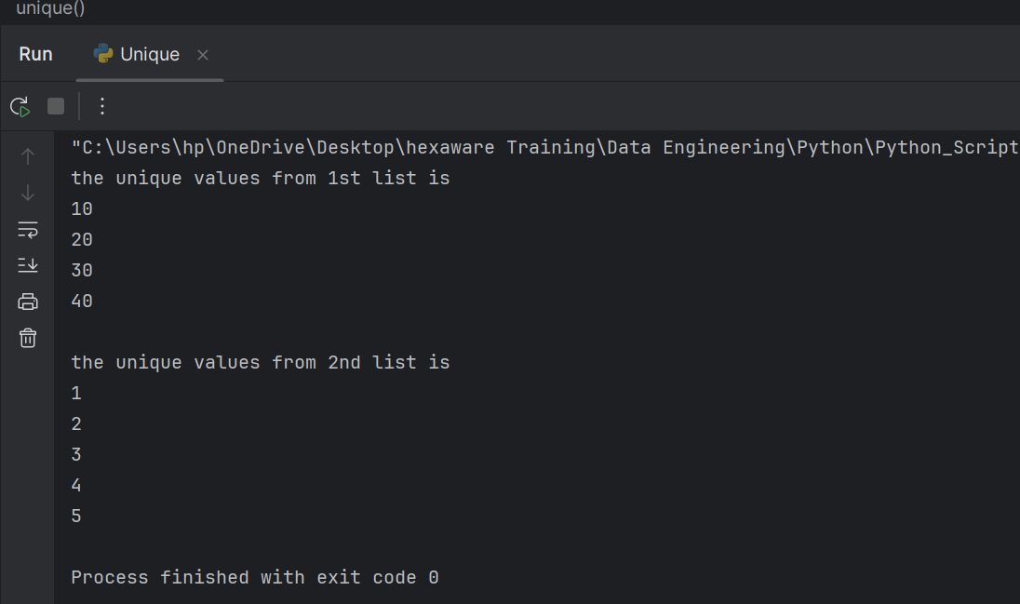

**Json**

**Code:**

import json  
  
data = '''{  
 "name": "John Doe",  
 "age": 30,  
 "city": "New York"  
}'''  
  
# Convert Python object to JSON string  
json_string = json.dumps(data)  
  
# Convert JSON string back to Python object  
parsed_data = json.loads(json_string)  
  
print(parsed_data)  
  
nested_json = {  
 "person": {  
 "name": "Alice",  
 "age": 25,  
 "address": {  
 "city": "San Francisco",  
 "zipcode": "94105"  
 }  
 },  
 "languages": ["English", "Spanish"]  
}  
  
city = nested_json["person"]["address"]["city"]  
print(city)

**Output:**

